
THE CATHOLIC UNIVERSITY OF AMERICA
School of Architecture and Planning
Washington, DC, 20064

18 July 2016

Eric D. Shaw, Director
DC Office of Planning
1100 4th Street SW, Suite E650
Washington, DC 20024

RE: DC Office of Planning and Catholic University Design Fall 2016 Studio

Dear Director Shaw,

Thank you for the opportunity to work with the Office of Planning (DCOP) on an examination of the Greenleaf Public Housing site in Washington DC's Southwest quadrant as part of Catholic University's Architecture and Planning (CUArch) Fall 2016 graduate studio! We look forward to this collaboration and hope that it will help lead to a strong relationship between the town and campus.

Here is a draft proposal that outlines the goals, structure, partners, past work and budget for this collaboration. We look forward to hearing from you and working with you on this proposal.

Introduction: Urban Practice Philosophy
The Urban Practice Concentration is a track within CUArch's Master of Architecture program that interlaces architecture and urban design with planning and sustainable design. This approach can be best summarized as: “Operating within contexts”. For us, contexts are seen in their broadest sense: reciprocating and mutually beneficial situations and associations that are at once physical, social, historical and conceptual yet professional and intellectual. Ultimately our goal is help students develop critical urban thinking that, as I'm sure you know, requires a constructive and modest examination, analysis and respect of contexts while anticipating an indefinite future.

Urban Practice Concentration instructors advocate an ethic that architecture is a social act. Working always as team critics (we rarely teach alone), we ask students to engage in contexts in a multi-scalar symbioses of urban fabric and architecture following Eliel Saarinen’s reminder to “Always design a thing by considering it in its next larger context - a chair in a room, a room in a house, a house in an environment, an environment in a city plan”. Furthermore, students compare architectural typologies and urban morphologies against conventional and unconventional practices to reconcile the past with contemporary spatial needs. Students examine varied sites with a scalar glissando in which urban design informs detail and, correspondingly, detail informs urban design. Like the scalar glissando, Urban Practice students work simultaneously in groups and individually. They come to understand and appreciate that architecture is produced in collaboration and through individual effort.

Fall 2016 Scope of Work
The DC Housing Authority is currently planning the redevelopment of many its housing properties along a choice neighborhoods model to create mixed income communities that will foster opportunity for existing residents, and help finance the rehabilitation of deteriorating housing stock. Currently, DCHA is examining the redevelopment of Green Leaf Gardens and DCOP is looking to investigate and explore new high-density housing typologies for creating family supportive mixed income communities. CUArch proposes a Fall 2016 graduate design studio for SW DC to investigate current international and domestic social housing typologies, spatially test ideas within the Southwest DC context, and develop design proposals. Some of the questions we hope to examine are: What kind of spatial configurations encourage the greatest social mixing and integration? How do you design for families and other special need groups in high density housing? What lessons and urban design qualities can be derived from the Southwest Urban Renewal Plan for creating new positive planning interventions in the city? What are the successes and failures of New Urbanism in city rebuilding?

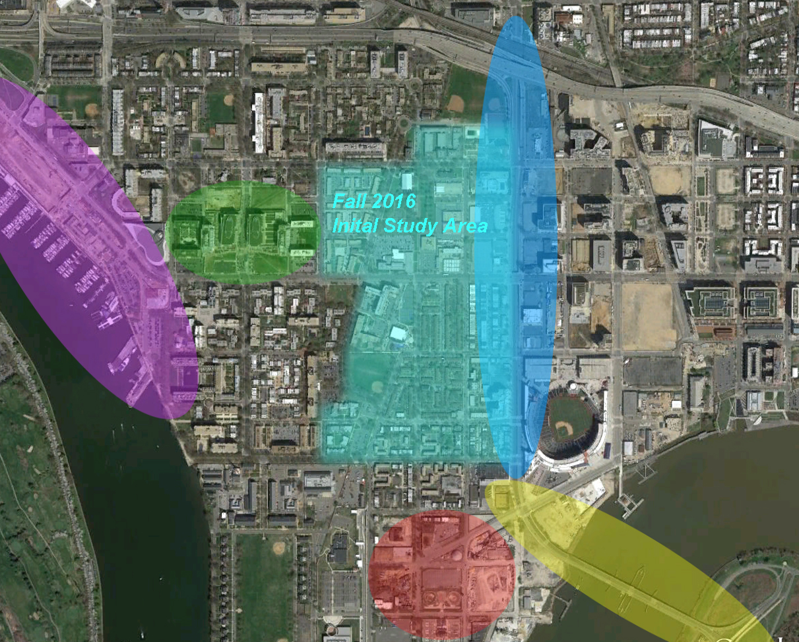
This plan shows the studio's initial scope in the context of adjacent critical areas or plans: the Wharf, 4th and
M Street Development, South Capitol Street, Douglas Bridge and the DC United Stadium.

Fall 2016 Urban Practice Process and Methodology
For the past decade, Mark McInturff and I (along with other instructors) continue to refine an approach to urban architecture that takes students through research and careful analysis to culminate in high quality design.

While not always as linear, we do have an outline of that process:

Part 1 (Teams and Sub-Teams)
A. Information Gathering (documentation, interviews, history, concepts, etc./daily briefings)
B. Initial Existing Condition Analysis (pattern, living / use, spatial relationships, income, etc.)
C. Precedent Documentation and Analysis / Theoretical/Conceptual Discussion (parallel)
An aspect of Part 1, are one-week trips to see exemplary urban design and architecture that are both conventional and unconventional. Past trips have included The Netherlands, Germany and Spain.

Part 2 (Teams and Sub-Teams)
D. Defining the Problem (essential issues to address)
E. Proposing Multiple Urban Strategies (varied to address issues)
F. Honing to a One or Two Strategies (Strengths, Weaknesses, Opportunities and Threats)

Part 3 (Individual or Teams of 2-3)
G. Architectural Testing of those Strategies: Tactics (fleshing out the strategies--architectural scale)

Part 4 (Teams and Sub-Teams)
H. Re-Inserting Tactics to Refine/Re-define the Urban Strategy (urban strategy development)

Theoretical and Conceptual Basis
Students critique urbanisms through documentation, analysis and synthesis. We do not advocate one particular urban doctrine but ask students to study conventional and unconventional practices to reconcile the past with contemporary spatial needs. While CUArch is where New Urbanism began (Andres Duany and others developed the idea while teaching at our Summer Institute of Architecture in the early 1980s), we question established methods to help develop strategies responsive to context -- especially, needs of the city and its residents.

For Southwest, this means investigating the mid-century intentions and results in order to understand what worked and what didn't. It would be easy to disregard Southwest's urban design and architectural typologies and paste over a "new" strategy that, like the well-intentioned mid-century solution, are seen as THE solution. Rather than replacement, we are eager to know what has worked and how we might move forward and reweave the unique fabric.

As part of this studio, we include readings and lectures to strengthen the historical and conceptual framework. Likewise, OP’s Senior Urban Designer, has offered to develop a theory component around designing for people and presenting concepts of sociability and livability in architecture.

Lastly, we will collaborate with DCOP to develop a balance of top down-bottom up design approach. While we understand that this study should remain a theoretical reply to current urban design proposals (and that we should refrain from involving the public), we will let DCOP act as the public who will inform the design strategies.

Past Urban Practice Studios
As mentioned, Urban Practice studio has worked on other similar, large scale projects in the United States and abroad. Past projects have been in settings needing repair and spatial solutions that address 21st century challenges that students will face in their careers. For example, how architects and urban designers work within historic settings, how will they use "unusable" sites and how will they re-conceptualize the city?

In each past project, students have produced high-quality, often award winning and published research and analysis with urban and architectural designs.

Past projects include:
Washington, DC's Union Market: Urban Food Hub (2015)
Baltimore's Terrain Vague: The Jones Falls Valley (2014)
Greenbelt: A 2037 Vision (2013)
The Jersey City Harsimus Stem Embankment (2012)
Berlin’s Topography of Terror Museum and Gardens (2007)

More detailed examples of the work and intentions can be found in the attachments to this proposal.

Collaborative Work
Urban Practice studios are about collaboration and DCOP will a welcome team member. While Mark McInturff, FAIA and I will be the primary studio critics, we will continue the sponsorship of Hickok-Cole Architects (HCA) who provide professional advice and expertise on zoning, development and practices. Todd Ray, principal at Studio 27 Architecture (S27) and author of the book (A)Mending L'Enfant's Plan: Southwest DC, will consult with us on the quadrant's history and its urban and architectural form. Additionally, we will have lectures and consultations with regionally and nationally recognized architects and urbanists such as Marion Weiss (Weiss-Manfredi), Karl DuPuy (Prof. Emeritus at UMD) and perhaps representatives from Gehl Architects in Copenhagen.

We hope to present the work at DCOP and, of course, invite you and your staff to campus at anytime. Our studio meets Monday, Wednesday and Friday, 2:10-6:00. Classes begin on 29 August and conclude 6 December. The exact deadlines and review dates will be determined this month.

Team Websites:
Eric J. Jenkins, AIA, Professor http://faculty.cua.edu/jenkinse
Mark McInturff, FAIA, Adjunct Professor http://mcinturffarchitects.com
Hickok-Cole Architects (Michael Hickok, FAIA and Yolanda Cole, FAIA) http://www.hickokcole.com
Studio 27 Architects (Todd Ray, FAIA) http://www.studio27arch.com

Budget
As part of the Urban Practice studio's intensive research and design, we ask students to engage with practitioners and theorists, to travel and see alterative urban design and architectural typologies and to produce multiple iterations.

With the help of DCOP, we hope the following budget will help us achieve these goals.

Item | Budget
Student Travel (Europe)  Housing / Ground Transportation | $7,000
Invited Lecturers (honoraria, transportation)  Karl DuPuy (Prof. Emertius UMD)  Marion Weiss (Weiss-Manfredi) | $2,000
Model Building Supplies | $2,000
Total Requested from DCOP | $11,000

Conclusion
Please let me know if you have any suggestions or questions. This is a working document and a studio that prides itself on adjusting to the needs of partners. As you well know, that's the beauty of collaboration.

Sincerely yours,

Eric Jenkins, AIA
Professor

cc: Mark McInturff, FAIA
Thor Nelson, DCOP

